CRYPTOGRAPHY AND NETWORK SECURITY PROJECT

GROUP MEMBERS

1. [121715] Wayne Kipruto
2. [117919] Shem Bonga

Deliverable 1

Website and Database Creation

The images below show both the website and database connection with inserting data being successful to the database.

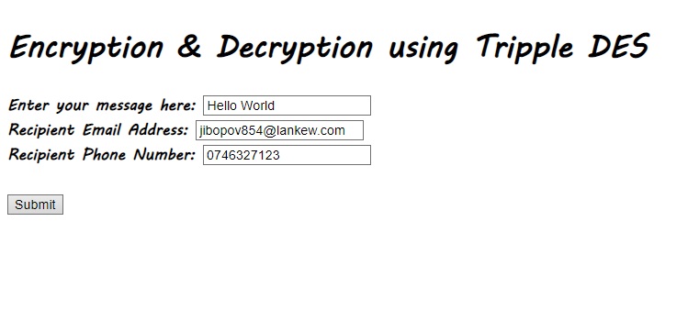

Figure :WEB FORM



Figure : Form data successfully pushed

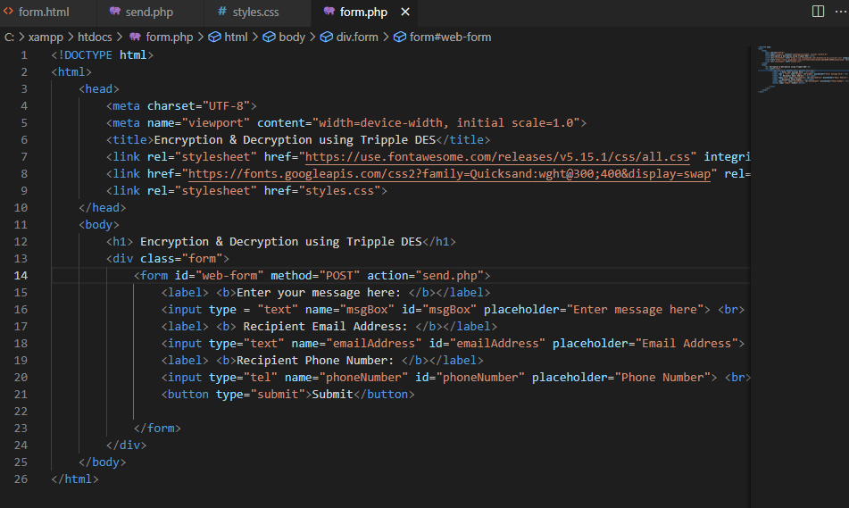

Figure :HTML CODE